Poster Introduction

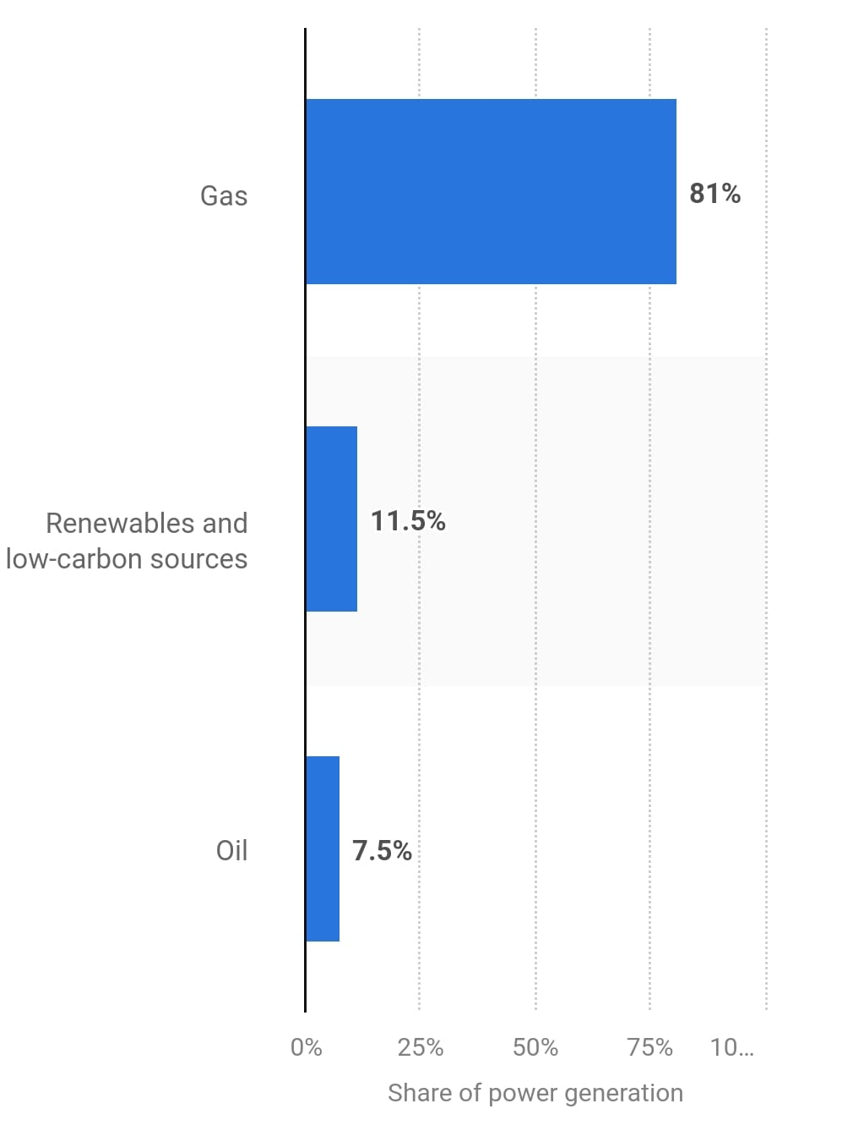
Improving the use of alternative energies is one of Egypt’s main grand challenges. For instance, Egypt uses non-renewable sources of energy for main electricity generation. Most of Egypt’s energy comes from fossil fuels, consisting of oil and gas. As illustrated in Figure 1. As a result, CO2 emissions are around 217.806 Megatons reaching 0.6% of the global emissions according to IEA. This causes an increase in temperature, climate change and pollution to the air, soil and water which brings us to the next grand challenges, “Address & reduce pollution in air, water, and soil” and “Work to eradicate public health issues”. Which combined cause disease outbreaks and major health concerns. To all solve all three challenges, “Reducing Power Shortage Through Alternative Energy” was chosen to be the problem to be solved.
Figure 1
After research, a multitude of solutions already tried were found and studied, two of which were Dogger Bank Windfarm and Benban Solar Park. Dogger Bank Wind Farm is a facility built to generate electricity from the wind in the United Kingdom, one of its strengths is reduced maintaince cost and mechanical wear as it uses a direct drive (gearless) system that provides lower energy loss and high efficiency. On the other hand one of its weaknesses is its large size which causes logisitical challenges as the turbine’s nacelle weighs over 600 tons, and the blades are 107 meters long, making transportation and installation difficult. As for Benban Solar Park, One of its strength points is its enviromental impact as it cuts CO₂ emissions by 2 million tons annually, reducing air pollution and combating climate change. Despite that it still has weaknesses, one of which is land use challenges because the 37 km² solar park occupies vast desert land, which could used in other sectors such as agriculture.
Therefore, after research analysis of the prior solutions, grand challenges and the design requirements which state that the prototype produces at least 0.04 kWh in at most 5 minutes and it not exceeding 0.5 m3 in volume, a Double-helix VAWT wind turbine was chosen as the selected solution.

